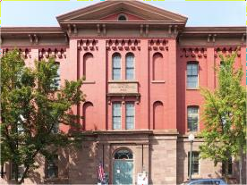
+
SCHUYLKILL COUNTY HISTORICAL SOCIETY
305 North Center St. • Pottsville, PA 17901 • 570-622-7540 sch.hist@comcast.net

Membership Application/Renewal
Please make checks payable to Schuylkill County Historical Society (SCHS)

I would like to make an additional contribution to:
Third Floor Renovations for Education Center _____________
Educational Programing and Community Outreach _____________
Archival Preservation – Preservation of Schuylkill County History _____________
Acquisitions for Museum _____________

Membership includes newsletter sent by email.
If you choose postal service, add $5.00 Waived if patron and above.

(Circle one)
INDIVIDUAL $30.00 PATRON $100.00
STUDENT $15.00 BENEFACTOR $250.00
FAMILY $45.00 BUSINESS $250.00
CONTRIBUTING $60.00 FIRST DEFENDERS $500.00

Newsletter (check one) Email USPS …... Add $5.00

Name ____________________________________________________________________
Address __________________________________________________________________
City _____________________________________ State _________Zip ______________
Email ____________________________________________________________________
Amount Enclosed:

We offer 3 ways to pay for research:
Check (made out to Schuylkill County Historical Society)
Credit Card: Credit Card ______ - ______ - ______ - ______ Exp _____ / _____
Security Code _____ Amount to Charge $ _______
PayPal: PayPal.Me/schuylkillcountyhist

